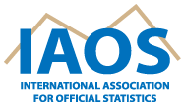

2026 General Assembly Meeting
13 May 2026, 12.30pm-2.00pm (EEST) (UTC +3) / 11.30am-1.00pm (CEST; UTC+2)
Radisson Blu Hotel Lietuva, Vilnius, Lithuania
Hybrid meeting
(please write to angie.simms@stats.govt.nz to receive the link)

AGENDA

- Minutes of 2025 General Assembly
- IAOS Annual Report
- Statistical Journal of the IAOS (SJIAOS)
- Young Statisticians Prize
- IAOS Strategic Plan 2025-27
- IAOS 2028 Conference
- Other business

