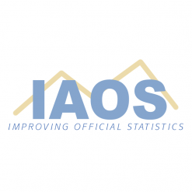 | 2026 IAOS Young Statisticians Prize
Do you work for an agency that produces official statistics?
Have you got something interesting to share with the official statistical community?
Are you under 35 years?
Are you interested in attending an International Conference,
maybe the 2027 ISI World Statistics Congress in Busan, Republic of Korea?
Enter the 2026 IAOS Young Statisticians Prize
Mr. Hanan Ather (Statistics Canada) won first place prize in 2025 for his research into large language models (LLMs) featured in his paper “LLM-Assisted Record Linkage: Framework for Record Linkage in Official Statistics.” Hanan received a cash prize of €1,500 and a two-year IAOS membership and certificate acknowledging his success in the competition. In addition, the IAOS will fund registration fees, airfare, and hotel accommodation to present his paper at an international conference agreed between he and the IAOS. Prize money is also offered for 2nd & 3rd.
The 2020 first place prize winner, Ms. Kenza Sallier, also from Statistics Canada, shared her experience in participating in the Prize in a very inspiring presentation which we encourage all potential entrants to view at https://vimeo.com/433593258/b3bf3eb00e

Papers from developing countries (low and middle-income countries) are strongly encouraged
Details of how to apply can be found at
https://www.iaos-isi.org/ysp
Entries must be submitted before 11:59 pm (UTC) on 10 April 2026

