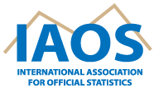

2024 General Assembly Meeting
Thursday, 16 May 2024, 8:00 - 9:00 (CST; UTC-6)
Hilton Reforma Hotel, Mexico City
Hybrid meeting
(please write to e.bandurska@stat.gov.pl to receive the link)

AGENDA

- Minutes of 2023 General Assembly
- IAOS Annual Report 2023-2024
- Draft Updated IAOS Statutes
- Statistical Journal of the IAOS
- Young Statisticians Prize
- IAOS conference plans
- Other business

