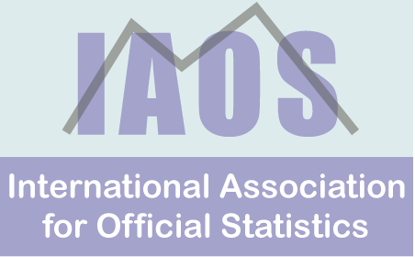

IAOS Celebrating 30 years: 1985 -2015
IAOS Members’ update – October 2015

Dear fellow IAOS members and supporters,

Introduction
As the newly elected President, I firstly want to say how deeply honoured I am to serve as President of this magnificent Association and to be entrusted with an entity that is so important to many people. I do not take this responsibility lightly, and I want to thank the IAOS community for its confidence in me as the President of IAOS 2015-2017.
At the General Assembly in Rio de Janeiro, I had the privilege of presenting the draft strategy for 2015-2017. This strategy had been developed by members of both the previous and incoming Executive Committees. I'd like to thank them all for their efforts, and encourage all members to review the draft strategy and provide us with feedback. The strategy is expected to be launched on World Statistics Day - October 20, 2015. It will then set the framework for how the Association works with members, stakeholders and other interested parties.
As I noted in my inauguration address, the IAOS is a forward looking organisation, grounded in a legacy from previous IAOS Presidents. This legacy is a commitment to excellence and an eagerness to create knowledge together. This is reflected in our spirit of learning, transfer of know-how and collaboration. These cornerstones of strength are enhanced and shaped by the experiences of our diverse membership base who come from all over the world.
I have the special privilege of becoming President at a time when the IAOS has reached an important milestone - it is now 30 years old. On behalf of all IAOS members, I would like to congratulate and thank former Presidents and Executive Members and all who have contributed to the success of the Association over this period.
I particularly want to acknowledge my dear friend Professor Shigeru Kawasaki, the previous President. Under Shigeru's leadership, we achieved a number of significant events, including the first IAOS conference in South East Asia. With his support, we have also witnessed major developments in the SJIAOS and in the Young Statistician Prize. Shigeru's stewardship of the Association has also led to a steady increase in membership, combined with a stable financial situation. Thank you Shigeru for your leadership. You have given the incoming Executive a great base to build on.
Before I turn to some of the key items in this newsletter, I would also like to acknowledge and thank the 2013- 2015 Executive, who supported the Association so well. In particular, I want to acknowledge the extensive contribution of Nancy Gordon (USA) , who has undertaken a range of roles with the IAOS committee, over a number of years. During this time, she made a real difference to many projects, as well as the general operations of the Association. I'd also like to acknowledge the strong contributions of Naoki Makita (Japan) who served as Shigeru's Assistant, and in doing so, ably supported the 2013-2015 Executive.
This issue of the Members Newsletter brings together many items of interest to members. While some items relate to activities held during the WSC in Rio; our focus as an Association has now also turned to the future. The new Executive Committee is already hard at work. Detailed preparation for the IAOS 2016 is well underway. The call for ISPs for the WSC 2017 has now been made, the YSP 2016 has been launched, the next issue of the SJIAOS is now published, and the Executive is also busy on a number of projects to progress the Strategic Plan.
The newsletter contains more details, including some photos from Rio.
I encourage you all to become involved as we finalise and then implement the IAOS strategy. It is an exciting time to be involved in Official Statistics and the IAOS is a great organisation to be part of.
Ola Awad
IAOS President 2015-2017

Key Upcoming Dates for IAOS Members
September Quarter 2015 issue of SJIAOS now available
World Statistics Day - 20 October 2015 - Don't forget to share your news and pictures
YSP 2016 closes on 15 December 2015

IAOS Strategic Plan

The draft of the 2015-2017 IAOS Strategic Plan was presented to the General Assembly in Rio de Janeiro. The strategy aims to provide answers to simple yet challenging questions about the role of IAOS in the global statistical community, in particular

What really makes IAOS special or different!
What does IAOS aim to achieve during the next two years?
How do users perceive IAOS? What do members want from IAOS?

The strategy resides on four objectives that focus on people – you - our members
Relevancy to ensure IAOS remains attractive to its members, and to other peer organizations
Visibility in various statistical events to maintain appropriate role in global statistical directions
Partnership with peer organizations to better serve the global statistical community
Institutionalize the work of IAOS so that in the future the focus shall be directed to development issues more than managerial matters

An associated work programme, with some ambitious, yet I believe achievable targets has been prepared to ensure that the strategy is implemented.

Developing the strategy, and associated work programme involved extensive input from both the 2013-15 Executive Committee and the incoming 2015-17 Committee. I would like to thank them for their input.

I encourage all members to read the strategy in detail and provide comments to the President at contactIAOS@gmail.com. The final strategy will be released as part of World Statistics Day on October 20, 2015.

Sometimes, unintentionally , we forget that IAOS is just a voluntary organization and we intentionally demand more- because everyone wants a distinguished IAOS. So in demanding more from the IAOS, we ask all of our members to identify where they want to be more involved in delivering on the strategy and work programme. Contact the President at contactIAOS@gmail.com on how you can help deliver on the strategy.

2015 IAOS General Assembly
A large number of IAOS members and supporters attended the General Assembly held during the WSC in Rio de Janeiro.

Our outgoing President, Professor Shigeru Kawasaki presented the IAOS Report 2013-2015. Highlights of the report include the progress achieved on the three pillars of the IAOS

A. IAOS Conferences
B. Young Statisticians Prize (YSP)
C. Statistical Journal of IAOS (SJIAOS)

As Professor Kawasaki noted at the General Assembly, the success of these three pillars was due very much to members, governments and international organizations that provided support.

Professor Shigeru also reported on the steady growth in membership and the healthy financial state of the association.

Current SJIAOS Editor in Chief Fritz Sheuren also briefly addressed the General Assembly and noted the significant progress with the journal. He encouraged members and supporters to continue to contribute to and read the journal.

The General Assembly also saw the formal inauguration of the 2015-17 President, Ms Ola Awad and the new Executive Committee. (More on the new Executive Committee below).

The new President expressed how deeply honoured she was to serve as President. Ms Awad reminded the Assembly that the IAOS had been established in 1985 to promote the understanding and advancement of official statistics. She noted that successive Presidents and Executives has handed down a commitment to excellence and an eagerness to create knowledge together. These cornerstones are reflected in the spirit of learning, transfer of know-how and collaboration.

Ms Awad also introduced the 2015-17 strategy (described above). Finally, the General Assembly concluded with an invitation from H.E. Butti Al Qubaisi, Director General of the Statistics Centre Abu Dhabi to the IAOS2016 conference which will be held in Abu Dhabi in December 2016. You can see more about this exciting venue for the conference here.

Photo highlights from the General Assembly follow

Immediate Past President, Shigeru Kawasaki, presenting his 2013-2015 Report | 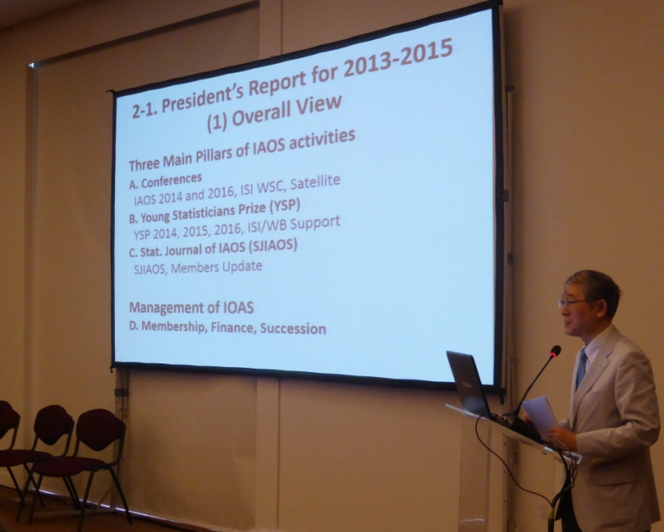

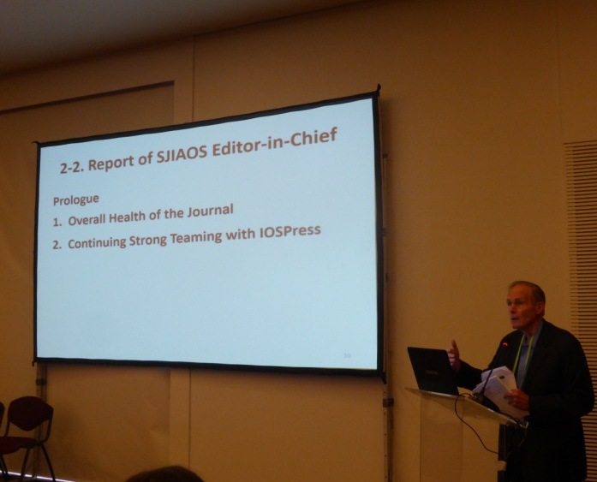 | SJIAOS Editor in Chief, Fritz Scheuren, discussing some of the recent developments in the Journal

Newly elected IAOS President, Ola Awad, introducing the IAOS 2015-17 Strategy
President Elect Mario Palma, President Ola Awad and immediate past President Shigeru Kawasaki, at the conclusion of the 2015 General Assembly

Conferences

WSC 15
After a long lead-in process the 60th ISI WSC at Rio de Janeiro, Brazil WSC was successfully held in late July 2015. The WSC contained 18 IPS sessions (out of an original 26 proposals) directly sponsored by the IAOS and 2 more sponsored jointly with the IASS. This total of 20 IAOS Invited Paper Sessions represented a significant increase on the number of accepted papers from the 59th ISI WSC in Hong Kong, where 10 sessions were sponsored by the IAOS.

Some other sessions that were not accepted as IPS were included as Special Topic Sessions on the program. This reinforced the relevance and presence of the IAOS at the Congress.

The IAOS Executive would especially like to thank Rolando Ocampo from INEGI, Mexico, who represented the IAOS on the WSC 15 Scientific Committee and co-ordinated the IAOS submissions. The IAOS Executive would also like to thank the organisers of all the IAOS sponsored sessions, the speakers, chairs and discussants.

There were many other highlights at the WSC, some of which are also discussed elsewhere in the newsletter. One of these was the special invited sessions directly organised and sponsored by the Association Presidents. The IAOS President's session "Towards Integration of Statistical and Geospatial Information" showed how geography and official statistics are moving even closer together. Another highlight was the IAOS Journal session organized by the SJIAOS Editor-in Chief, Dr Fritz Sheuren, focusing on indigenous populations, entitled "Measuring Indigenous Populations Across Nations: Challenges for Methodological Alignment

If you missed any of the IAOS sponsored sessions in Rio, you can read the papers in a later issue of the journal.

IAOS16

The 2016 conference will be held in Abu Dhabi, UAE from 6-8 December 2016. The overall conference theme of The Spirit of Official Statistics: Partnership and continuous innovation, encompasses four themes that the sessions will address:

- Strengthening the value of official statistics in the rapidly expanding information society
- Partnership in action for results
- Innovation and Modernization of National Statistical Systems
- Fundamental Principles in practice

These are all key strategic issues impacting on producers and users of official statistics.

Deadlines for the call for session organisers and papers will be available soon.
In the meantime, if you have any questions about the program, contact Eric Rancourt, IAOS 2016 Program Chair at Eric.Rancourt@statcan.gc.ca

A reminder also to watch the welcome video here.

WSC 17
The Executive is very happy to announce that Rolando Ocampo has agreed to be the IAOS representative on the Scientific Committee for the WSC17 to be held in Marrakech, Morocco from 16-21 July, 2017. The general call for ISPs has been made on the ISI website. More information about the IAOS process for sponsored sessions will be announced in the near future.
More information about the WSC17 can be found here.

International Association for Statistical Computing (IASC) - Asian Regional Section (ARS) 2015 conference (IASC - ARS 2015)
This will be held at the National University of Singapore on 17-19 December 2015. More information about the conference can be found here.

Fifth International Conference on Establishment Surveys (ICES-V)
This conference will be held from June 20-23, 2016 in Geneva, Switzerland. See more

34th General Conference of the International Association for Research in Income and Wealth (IARIW)

The IARIW conference will be held in Dresden (Germany) from 21 to 27 August 2016. The conference will encompass many issues that are at the top of the agenda of politics, economics and society: financial and economic vulnerability, sustainability, economic growth, globalization, productivity, well-being, ageing population or inequality in the distribution of income and wealth. Detailed information about conference topics and submission of abstracts is available here

Seventh International Conference on Agricultural Statistics (ICAS VII)

The Seventh International Conference on Agricultural Statistics (ICAS VII) will take place in Rome - Italy, 26-28 October 2016. The theme of ICAS VII is the “Modernization of Agriculture Statistics in Support of the Sustainable Development Agenda”. For more information see the conference website http://icas2016.istat.it.

Young Statistician Prize (YSP)

YSP 15
The winning paper from the YSP 2015 competition ""Big Data and Semantic Technology: A Future for Data Integration, Exploration and Visualisation", by Andreas Mayer and Andrew Harwood (Australia). was presented during the WSC in Rio de Janeiro.

All winners were also formally awarded their prizes at the ISI Awards Ceremony during the Congress.

Winning papers will be published in a future issue of the SJIAOS.

Andreas Mayer, one of the winning co-authors of the Young Statistician Prize 2015, presenting during the WSC in Rio de Janeiro

YSP 16 competition
The YSP 2016 competition is now open. The winning paper will be presented at the IAOS16 conference in Abu Dhabi, United Arab Emirates in December 2016. The closing date for YSP 2016 is 11:59pm on December 15, 2015.
Please encourage eligible young statisticians to enter. For more information on the announcement and the technical guidelines for this year's competition, see here.
Posters in all six official UN languages are now available on the IAOS website - see here We encourage you to use this poster to publicise the competition. The associated interview with the winners of the YSP15 competition can be found here.

SJIAOS

September 2015 Quarter - Update -
The September quarter issue, continues with the quarterly interview with a leader in official statistics. This quarter the interview is with Dr Denise Silva, Principal Researcher in the National School of Statistical Sciences in the Brazilian Institute of Geography and Statistics (IBGE). In the interview, Dr Silva reflects on her career with IBGE, as well as her time with the UK Office for National Statistics and lecturing with the University of Southampton. The interview is open to all readers.

Dr Denise Silva, Principal Researcher in the National School of Statistical Sciences in the Brazilian Institute of Geography and Statistics (IBGE), interviewed in the September 2015 quarter issue of the SJIAOS. | 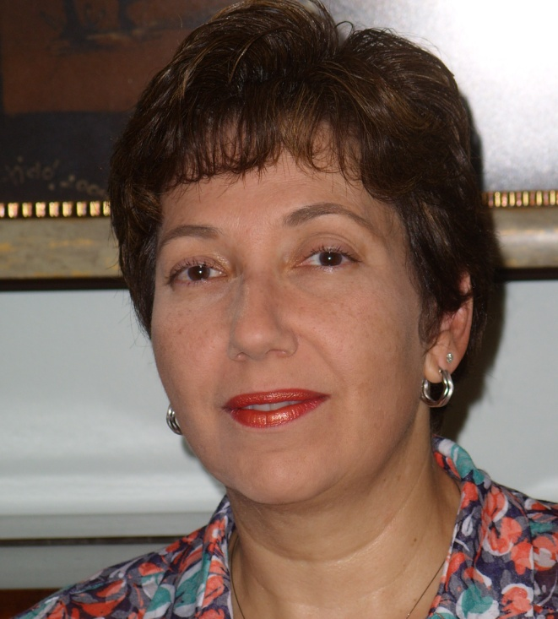

Every issue of the Journal offers a theme. In the September issue that theme is on the international refugee crisis. For this reason the paper by Capps et al, is also available in an open format.

In this issue, the editors have introduced a new feature, also open to all readers. The journal is pleased to announce a new series of conversation - covering topics which go beyond individuals or countries. The pilot conversation is with the Cathy Furlong of Statistics without Borders (SwB) - the organisation that provides pro bono statistical assistance to organisations worldwide. The editors welcome suggestions for other potential conversations. Contact the Editor in Chief, Fritz Sheuren at scheuren@aol.com.

But the September issue is not just about interviews - there are papers on Modernising Censuses; practices in official statistics , discussions about the fundamental principles; data quality and in particular the challenges of fabrication of data, big data and more. Much to read and think about, as always. (If you miss the email announcement launch announcement from the Editor in Chief - the IAOS website will also keep you informed of the latest issue.)

Appointment of the next Editor-in-Chief of SJIAOS
The IAOS Executive Committee is pleased to announce that we have appointed Dr. Kirsten West as the next Editor-in-Chief of the Statistical Journal of the IAOS (SJIAOS). Dr West will take over from the current editor, Dr Fritz Scheuren in the first half of 2016. See more

New processes for IAOS members to access the SJIAOS
A reminder to all members that the process for accessing the journal changed in June 2015. The previous IAOS username and password are no longer valid. Members are asked to register themselves at http://content.iospress.com (Go to the Register tab) and once done, to send an email to Ms. Kim Willems (k.willems@iospress.nl).See here for more information

IAOS Executive Committee News

Introducing the IAOS Executive Committee for 2015- 2017
The new IAOS Executive Committee took up their responsibilities after the 2015 General Assembly and have already been hard at work. The Executive Committee members, with their areas of responsibility are:

- Ola Awad, President 2015-2017, specific responsibilities include IAOS 2016 conference, IAOS Website upgrade
- Mario Palma, President Elect, specific responsibilities include IAOS2018 conference
- Leslie Tang, responsible for Young Statisticians Prize (YSP)
- Oliver Chinganya, responsible for Membership Campaign,
- Sybille von Oppeln-Bronikowski, responsible for IAOS Ethics and relationships with ISI
- Nancy McBeth, responsible for Membership Communication, Website Upgrade
- Teodora Brandmueller, SCORUS representative
- Ada van Krimpen , Director ISI and Ex Officio member of Committee

They are supported by
- Fritz Scheuren. Editor in Chief, SJIAOS and Kirsten West, Editor in Chief -elect, SJIAOS
- Rolando Ocampo, IAOS Representative to ISI-WSC Scientific Programme Committee, 2017
- Eric Rancourt, IAOS 2016 Program Chair

Over the next few months, the Executive will be working to finalise the 2015-17 Strategy, develop a plan for the redevelopment of the website, publicise the YSP 2016 competition, identify options for increasing membership, conduct a membership survey, strengthen links with other parts of the ISI family, progress the scientific programme for the IAOS16 conference and support the call for papers for the ISP part of the programme for the 2017 World Statistical Congress.

Below is a picture of many of the EXCO at Rio, before they commenced on this busy work programme.
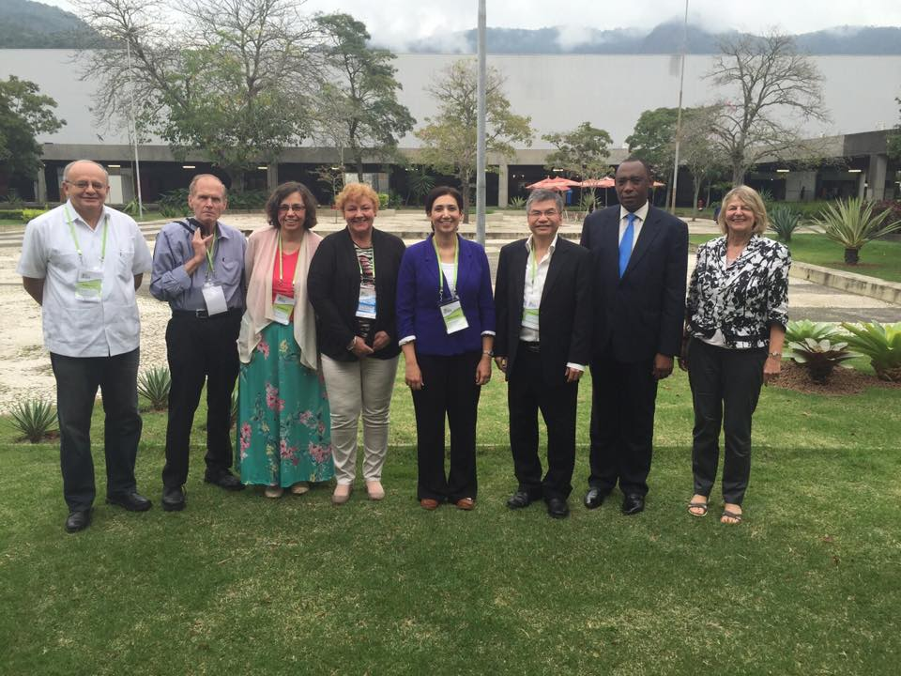
From Left to Right Mario Palma, Fritz Scheuren, Nancy McBeth, Ada van Krimpen, Ola Award, Leslie Tang, Oliver Chinganya, Sybille von Oppeln-Bronikowski

Absent: Teodora Brandmueller, Rolando Ocampo, Eric Rancourt

If you are interested in working with one of the EXCO on any of these projects, contact the President at contactIAOS@gmail.com.

Other Items of interest to IAOS members

World Statistics Day

On 20 October, we once again celebrate World Statistics Day.
The first World Statistics Day on October 20, 2010 was commemorated in more 130 countries and areas. 2015 marks an important confluence for official statistics, with the conclusion of the Millennium Development Goals, the post-2015 development agenda, the data revolution, the preparations for the 2020 World Population and Housing Census Programme and so much more.
To kick off this special global event, the UN has launched a website and released a kick-off video unveiling the celebration’s logo.
The IAOS will be launching the 2015-2017 strategy on World Statistics Day. There will be more about this on the website and in the next Members Newsletter.

We're also keen to share other news of World Statistics Day in the world of official statistics. We'll publish photos on the website and in the newsletter. Contact our Website Editor Nancy McBeth at nancyemcbeth@gmail.com, with your news and pictures.

Other ISI Association activities

International Association for Statistical Computing (IASC) - Asian Regional Section (ARS) 2015 conference -( IASC - ARS 2015) This will be held at the National University of Singapore on 17-19 December 2015. More information about the conference can be found here.

Invitation to share other items of interest to members.
We welcome short items of interest to members of the IAOS, official statisticians, providers and users of official statistics for publication in this newsletter and/or on the IAOS website. Please send your contributions to contactIAOS@gmail.com or nancyemcbeth@gmail.com.

Finally I really welcome any feedback and suggestions that you may have on matters relating to Official Statistics and the work of the IAOS in particular. I look forward to your continued interest and support in the IAOS activities.
Thank you again for your support

Ola Awad
President IAOS

Contact names and email addresses:
Ola Awad (President) contactIAOS@gmail.com
Mario Palma (President Elect) mpalma@inegi.org.mx
Fritz Scheuren (Editor, SJIAOS) scheuren@aol.com
Eric Rancourt ( IAOS 2016 Program Chair) Eric.Rancourt@statcan.gc.ca
Rolando Ocampo IAOS representative on the 2017 WSC Rolando.Ocampo@inegi.org.mx
Nancy McBeth (IAOS Website Editor) nancyemcbeth@gmail.com

